Low Level Dynamic Hooks with Binary Computations and Logic Gates

Aim
The aim of this feature is make it comfortable for users with an impairment to change keys or create shortcuts to tasks using combinations
It itself is also an accessibility feature for other features eg., customization control to toggle an accessabilty feature on or off .
Relevance could be:
Impairment
Broken touchpad
Broken keyboard
Customisation of events or actions

My goal with this aim is to make constant global hooks previously made dynamic upon user choosing . They must use a modifier key and a virtual key and the app responds back. Stating there choice and then registering it globally across the whole computer .
They can change it anytime they like and the application will show the change back to them and implement the change .

Binary Theory ( proof on concept math’s at end of document )
To make this work I need to know what each key combination results in . Bits are the building blocks in a binary – either on or off in a specific order. The value of a bit is its relative position in the binary. The literal value is worked out by calculating its exponential by its position .

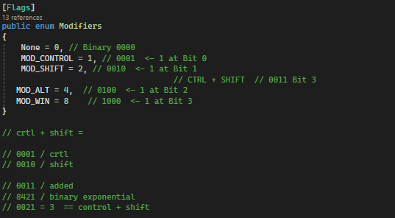
Flags are used
Windows uses message loops to make sure apps handle events like mouse clicks.Message loops are basically windows repeatedly calls GetMessage all the time and then sends them to the right window open using its HWND (handle to window)-> the windows id. This keeps the app responsive .
.GetKeyStateFromCurrentThread
Each thread gets its own message loop when it first creates a window . Since message clicks should respond to the window in focus input events are put into this active thread only.
You can see here that the state of the virtual key is “down” pressed it uses a logic gate to add the binary of the key so it can be identified later if a possible join of another key is input into the same space in memory. This maths is described at the bottom of the page.

The Ui Is updated with the captured keys from the event using e.Key and properly casting back to an unsigned integer. Capturing is quit with a Boolean due to conditional statement allowing input if its true .
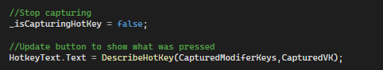
We make sure the hook is naturally set once upon initialization . Only when the user tries to change the hook code will activate.
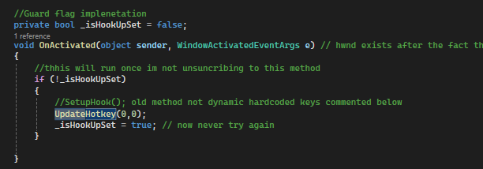
Dynamic linked libraries are imported and I follow the parameters to hook into a global input stream . This means in this case a hotkey of Mod Control or Mod Alt with VK 0 is registered to call certain logic even if the app is closed .
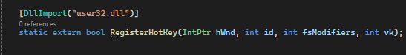

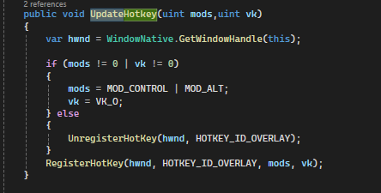
This null check works due to each binary operation returning false for every key – this would prove the user did not choose dynamically and it is set for them . If they just did set – then deregister.

Handle Deregistering
Windows native event of close is called upon pressing x – this in encapsulated method but it contains removing all references to unused memory . I can override it by subscribing to the event with += in the constructor of the Window .
Since this is only ever called in the settings page “ Kill All Processes” as the app works as a background service .
The user cannot mistakenly destroy background services by clicking as the window disables close but instead Is programmed to be a tool widow (hides references in the taskbar .

Binary Logic
This is how bit flags work under the hood . This example demonstrates how 3 = 2 + 4
- How to check multiple modifiers in the same binary in memory
- How logic gates work
- How binary values are computed

